Lampiran

Uji Validitas
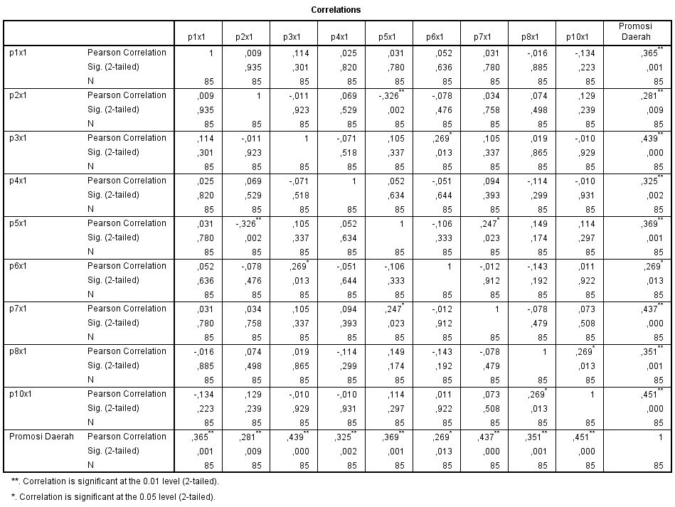

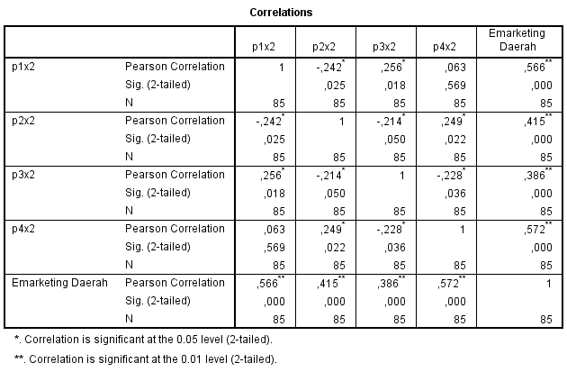

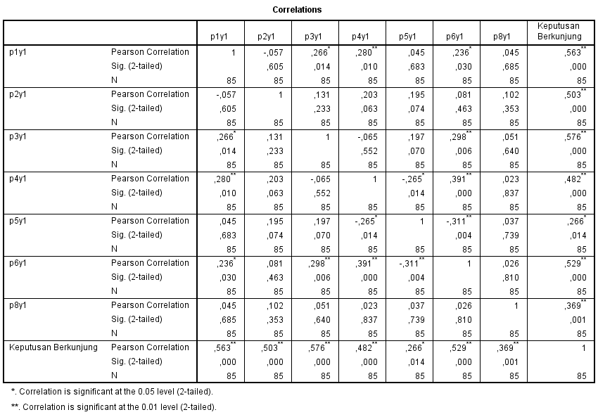

UJI RELIABILITAS

Item-Total Statistics
 | Scale Mean if Item Deleted | Scale Variance if Item Deleted | Corrected Item-Total Correlation | Cronbach's Alpha if Item Deleted
p1x1 | 135,7059 | 44,067 | -,025 | ,740
p2x1 | 135,6824 | 43,434 | ,073 | ,734
p3x1 | 135,6471 | 42,541 | ,218 | ,727
p4x1 | 135,6941 | 43,262 | ,084 | ,734
p5x1 | 135,6706 | 43,009 | ,145 | ,730
p6x1 | 135,6588 | 43,942 | ,004 | ,737
p7x1 | 135,6706 | 42,914 | ,160 | ,730
p8x1 | 135,7412 | 42,480 | ,215 | ,727
p10x1 | 135,6824 | 40,672 | ,444 | ,714
Promosi Daerah | 107,7412 | 33,075 | ,402 | ,724
p1x2 | 135,7059 | 42,353 | ,198 | ,728
p2x2 | 135,7059 | 40,853 | ,418 | ,715
p3x2 | 135,7176 | 42,205 | ,255 | ,725
p4x2 | 135,6706 | 40,700 | ,440 | ,714
Emarketing Daerah | 125,2706 | 33,390 | ,758 | ,669
p1y1 | 135,7647 | 41,039 | ,397 | ,717
p2y1 | 135,7059 | 41,115 | ,399 | ,717
p3y1 | 135,6588 | 40,608 | ,474 | ,713
p4y1 | 135,7529 | 42,141 | ,253 | ,725
p5y1 | 135,6941 | 43,596 | ,050 | ,735
p6y1 | 135,7765 | 41,557 | ,341 | ,720
p8y1 | 135,6353 | 43,520 | ,068 | ,734
Keputusan Berkunjung | 114,9294 | 29,400 | ,604 | ,687

Regresi Sub Pertama hubungan Promosi daerah dengan Keputusan Berkunjung

Model Summary
Model | R | R Square | Adjusted R Square | Std. Error of the Estimate
1 | ,003ª | ,000 | -,012 | 1,78956
a. Predictors: (Constant), Promosi Daerah

ANOVAª
Model |  | Sum of Squares | df | Mean Square | F | Sig.
1 | Regression | ,003 | 1 | ,003 | ,001 | ,976^{b}
1 | Residual | 265,809 | 83 | 3,203
1 | Total | 265,812 | 84
a. Dependent Variable: Keputusan Berkunjung
b. Predictors: (Constant), Promosi Daerah

Coefficientsª
Model |  | Unstandardized Coefficients |  | Standardized Coefficients | t | Sig.
 |  | B | Std. Error | Beta | t | Sig.
1 | (Constant) | 24,142 | 3,515 |  | 6,868 | ,000
1 | Promosi Daerah | ,003 | ,112 | ,003 | ,030 | ,976
a. Dependent Variable: Keputusan Berkunjung

Regresi kedua Promosi daerah sebagai variabel kontrol dan Emarketing dengan keputusan berkunjung

Model Summary
Model | R | R Square | Adjusted R Square | Std. Error of the Estimate
1 | ,698ª | ,487 | ,475 | 1,28928
a. Predictors: (Constant), Emarketing Daerah, Promosi Daerah

ANOVAª
Model |  | Sum of Squares | df | Mean Square | F | Sig.
1 | Regression | 129,507 | 2 | 64,753 | 38,955 | ,000^{b}
1 | Residual | 136,305 | 82 | 1,662
1 | Total | 265,812 | 84
a. Dependent Variable: Keputusan Berkunjung
b. Predictors: (Constant), Emarketing Daerah, Promosi Daerah

Coefficientsª
Model |  | Unstandardized Coefficients |  | Standardized Coefficients | t | Sig.
 |  | B | Std. Error | Beta | t | Sig.
1 | (Constant) | 13,682 | 2,796 |  | 4,894 | ,000
1 | Promosi Daerah | -,181 | ,083 | -,178 | -2,175 | ,032
1 | Emarketing Daerah | 1,168 | ,132 | ,721 | 8,827 | ,000
a. Dependent Variable: Keputusan Berkunjung

Uji Normalitas

One-Sample Kolmogorov-Smirnov Test
 |  | Unstandardized Residual
N |  | 85
Normal Parameters^{a,b} | Mean | ,0000000
Normal Parameters^{a,b} | Std. Deviation | 1,27384298
Most Extreme Differences | Absolute | ,059
Most Extreme Differences | Positive | ,059
Most Extreme Differences | Negative | -,058
Test Statistic |  | ,059
Asymp. Sig. (2-tailed) |  | ,200^{c,d}
a. Test distribution is Normal.
b. Calculated from data.
c. Lilliefors Significance Correction.
d. This is a lower bound of the true significance.

